**PONDICHERRY UNIVERSITY**

(A Central University)

**DIRECTORATE OF DISTANCE EDUCATION**

**Project Management**

**Paper Code : MBFM 3004**



**MBA - FINANCE**

**III Semester**

**TABLE OF CONTENTS**

|  |  |  |  |  |
| --- | --- | --- | --- | --- |
|  |  | **TITLE** |  |  |
|  |  | |  |  |
| 1.1 | Project Management – An Overview | |  |  |
|  |  | | |  |
| 1.2 | Project Portfolio Management System and Structure | | |  |
|  |  | |  |  |
| 1.3 | Steps in Defining Project and Project Delays | |  |  |
|  |  |  |  |  |
| 2.1 | Various | Stages and Components of Project | Feasibility |  |
| Studies |  |  |  |
|  |  |  |  |
|  |  |  |  |  |
| 2.2 | Phases | of a Project, Stages in Project Life | Cycle and |  |
|  |
| Project Constraints | |  |  |
|  |  |  |
|  |  | | |  |
| 3.1 | Project Evaluation under Certainty and Uncertainty | | |  |
|  |  | | |  |
| 3.2 | Project Evaluation, Commercial and Social Cost Benefit | | |  |
| Analysis | |  |  |
|  |  |  |
|  |  | | |  |
| 4.1 | Developing Project Network using PERT and CPM | | |  |
|  |  | |  |  |
| 4.2 | Crashing of Projects and Resource Leveling | |  |  |
|  |  | |  |  |
| 4.3 | Project Appraisal and Control Process | |  |  |
|  |  | | |  |
| 4.4 | Project Audit and Evaluation of Project Team its Project | | |  |
| Manager | |  |  |
|  |  |  |
|  |  | |  |  |
| 5.1 | Project Managing Versus Leading of Project | |  |  |
|  |  | | |  |
| 5.2 | Qualities of Project Manager and Managing Project | | |  |
| Teams |  |  |  |
|  |  |  |  |
|  |  | | |  |
| 5.3 | Team Building Models and Performance Teams and Team | | |  |
| Pitfalls |  |  |  |
|  |  |  |  |

**1.1 - Project Management – An Overview**

**Concept of Project**

**Project** is defined as temporary but interrelated tasks undertakento give a unique product or service or result. Projects are different from other ongoing operations in an organization, because unlike operations, projects have a definite beginning and an end - they have a limited duration. Projects are critical to the realization of performing organization’s business strategy because projects are a means by which the strategy of the company is implemented.

**A project** is a temporary endeavor, having a defined beginning andend (usually constrained by date, but can be by funding or deliverables), undertaken to meet unique goals and objectives, usually to bring about beneficial change or added value. The temporary nature of projects stands in contrast to business as usual (or operations), which are repetitive, permanent or semi-permanent functional work to produce products or services.

A project is an investment made on a package of interrelated time-bound activities; consequently, a project becomes a time-bound task. Every project has two phases basically; the first is preparation and construction, and the second, its operation. Project planning deals with specified tasks, operations or activities which must be performed to achieved the project

4

Notes

goals. Any project that we may consider has an objective, or a set of objectives, to achieve. It has to be operated within a given set of rules, regulations, constraints and restrictions. Implementation of projects needs resources or inputs. Every project converts the given inputs into outputs through a process of implementation. The outputs in the short run lead to outcomes, which, in the long run, should result in impact.



A project can be defined as a complex of non-routine activities that must be completed with a set amount of resources and within a set time limit. The following figure explains the basic tenets of project management.

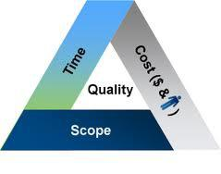

Typical examples of projects include: construction of a house, performing a marriage, overhauling a machine, maintenance of equipment, commissioning of a factory, conducting national elections, research on developing a new technology, launching a new weapon system, conducting a war, pre-crisis planning for preventing a riot, recruitment of a project manager, etc. Each of the above cases involves investment of resources on

1. package of inter-related, time-bound activities, thereby constituting a project.

Projects also involve one or more elements that have not been done in the past, and are therefore unique. A product or service may be unique even if the category to which it belongs is large. For example, although several residential complexes have been built in the past, creation of a new house will be a project because each facility can have elements such as a unique - location, customized or adapted design, regionally available resources, and/or discrete owners.

5

Notes

**Characteristics of a Project**



1. **Temporary:** Projects are temporary in nature. Every project hasa beginning and end. The word ‘temporary’ here may refer to an hour, a day or a year. Operational work is an ongoing effort which is executed to sustain the business. But projects are not ongoing efforts. A project is considered to end when the project’s objectives have been achieved or the project is completed or discontinued. Only projects are temporary in characteristic and not the project’s outcomes. It will not generally be applied to the product, service or result created by the project. Projects also may often have intended and unintended social, economic and environmental impacts that long last.Eg. Building Eiffel Tower was a project. The structure was built between 1887 and 1889. Project Eiffel Tower ended on 1889. But still the outcome of the project exists as a monument.
2. **Definite Beginning and Completion:** Project is said to becompleted when the project’s objectives have been achieved. When it is clear that the project objectives will not or cannot be met the need for the project no longer exists and the project is terminated. Thus, projects are not ongoing efforts. Thus, every project has a definite beginning and end.
3. **Definite Objective/Scope and Unique:** All the projects have theirown defined scopes/objectives for which they are carried out. Every Project is undertaken to create a unique product, service, or result. Eg. Hundreds of house buildings may have been built by a builder, but each individual building is unique in itself like they have different owner, different design, different structure, different location, different sub-contractors, and so on. Thus, each house building is to be considered as a Project and each Project produces unique outcome.
4. **Defined Time and Resources:** As the projects have definitebeginning and end, they are to be carried out within the time and resources constraints. Each project will have defined time and resources for its execution.
5. **Multiple Talents:** As projects involve many interrelated tasksdone by many specialists, the involvement of people from several

6





3

Notes



Notes

departments is very much essential. Thus, the use of multiple talents from various departments (sometimes from different organizations and across multiple geographies) becomes the key for successful project management. For example, take the construction of house building; the expertise of very many professionals and skills of various people from various fields like architect, engineers, carpenters, painters, plumber, electrician, interior decorator, etc, are being coordinated to complete the house project.



7

Notes

The two basic activities which normally get completed before undertaking the installation of equipment in any project are: (a) land acquisition, and (b) infrastructural development. Most of the projects are undertaken next to a river or road/railway junction, or a busy commercial centre with a view to cutting down the expenditure for developing the external infrastructure needed for the project, such as road/railway points, schools, commercial centers, and residential accommodation, which otherwise put a heavy burden on the project authorities. There is a general sentimental opposition from the landowners as well as tillers to handover their land for fear of losing their earning opportunities, and the project team must try to cope with such contingencies.

Notes

Notes

Notes

Notes



**Project Management**

Project management is the discipline of planning, organizing, securing and managing resources to bring about the successful completion of specific project goals and objectives. Project management is the application of knowledge, skills and techniques to execute projects

16

Notes

effectively and efficiently. It’s a strategic competency for organizations, enabling them to tie project results to business goals — and thus, better compete in their markets.It has always been practiced informally, but began to emerge as a distinct profession in the mid-20th century. It is no longer a special-need management. It is rapidly becoming a standard way of doing business. Project Management Institute’s *A Guide to the Project* *Management Body of Knowledge (PMBOK® Guide)* identifies its recurringelements. Project management processes fall into five groups such as *initiating, planning, executing, monitoring, controlling and closing.*



Project management *knowledge* draws on nine areas, viz., integration, scope, time, cost, quality, procurement, human resources, communications and risk management. All management is concerned with these, of course. But project management brings a unique focus shaped by the goals, resources and schedule of each project. The value of that focus is proved by the rapid, worldwide growth of project management as a separate area of study and as a mode of functioning.

17

18

Notes

.

19

Notes

**An Integrated Approach to Project Management**



Many project managers have tried many tools, techniques and systems to manage projects. These piecemeal systems fail to integrate the overall strategies of the organizations and connect the selected projects to resources. They also fail to balance the application of project planning and control methods with appropriate adjustments in the organization’s culture to support project activities. Thus, today’s project management environment requires an integrated approach. Integrated project management process focuses all project efforts towards the strategic plan of the firm and reinforces mastery of both the project management tools or techniques and interpersonal skills necessary to achieve successful project completion. Integration of project management has two key areas.

.

20

Notes

**Conclusion**



Without a scientific approach to the task of managing the projects and achieving objectives, it would be very difficult for the organizations to successfully execute the projects within the constraints of time, scope and quality and deliver the required result. In other words, there has to be a framework and a defined way of doing things to ensure that there is a structure to the art of project management. Thus, project management is about creating structure and managing the project commitments and the delivery of agreed upon results. Thus, Project Management is both necessary and essential to the success of the project. In conclusion, integrated project management and the practice of the same have become indispensable to the modern day project manager. The technical side of the project represents the science of project management and the socio-cultural side represents the art of managing the project.

****

21

Notes



**1.2 - Project Portfolio Management System and Structure**

Project Portfolio Management System (PPM) is a term used by project managers and project management (PM) organizations, (or PMO’s), to describe methods for analyzing and collectively managing a group of current or proposed projects based on numerous key characteristics. The fundamental objective of PPM is to determine the optimal mix and sequencing of proposed projects to best achieve the organization’s overall goals - typically expressed in terms of hard economic measures, business strategy goals, or technical strategy goals - while honoring constraints imposed by management or external real-world factors. Typical attributes of projects being analyzed in a PPM process include each project’s total expected cost, consumption of scarce resources (human or otherwise) expected timeline and schedule of investment, expected nature, magnitude and timing of benefits to be realized, and relationship or inter-dependencies with other projects in the portfolio.

Thus, Project Portfolio Management is about more than running multiple projects. Each portfolio of projects needs to be assessed by its business value and adherence to strategy. The portfolio should be designed

22

Notes

to achieve a defined business objective or benefit. Project management guru Bob Buttrick summarized it when he said; “Directing the individual project correctly will ensure it is done right. Directing ‘all the projects’ successfully will ensure we are doing the right projects.” Project portfolio management organizes a series of projects into a single portfolio of reports that capture project objectives and other critical factors. While at individual project level it is important to know how each project is performing, the impact of each project on the portfolio is also important. The following questions should be asked:



* Does each project contribute to the overall achievement of the portfolio?
* How well is each project performing?
* Will any project have a negative impact on other projects to come?
* What projects in the portfolio are dependent on others?
* Will the successful delivery of all projects deliver the desired objective or benefit?

Notes

**Design of Project Portfolio Management System**

Design of project portfolio management system should include the following:

**a) Classification of Project**

Most of the organizations may have three kinds of projects in their portfolio, viz., compliance and emergency projects, operations projects and strategic projects. Compliance and emergency projects are compulsory in nature to meet the regulatory conditions. Operational projects are those that are needed to support operations and are designed to improve efficiency of delivery system, reduce product costs, and improve performance. Strategic projects are those that are directly support the organizations’ long run mission. The strategic value of a project should be determined before it is placed in the project portfolio. However, compliance projects may also be undertaken to avoid regulatory problems.

**b) Selection Criteria**

Selection criteria for projects may be divided into financial and nonfinancial. Financial criteria are the most preferred method to evaluate projects. Common financial methods include payback method and net present value method. Payback method is a method in which the projects which pays back the original investment in a shorter period are given priority.

In case of net present value method, the project which gives positive NPV is selected. NPV is the excess of present value of cash inflows over present value of cash outflows. Non-financial criteria may include the

25

Notes

following: a) restoring corporate image or b) enhancing brand image. Many organizations are committed to corporate citizenship and support community development projects. Thus, the social desirability of the projects is also equally important as financial viability.



**c) Sources of Project Proposals**

Projects should originate from anyone who believes their project will add value to the organization. Many organizations restrict proposals from specific levels or groups within the organization. This could be an opportunity lost. Thus, project ideas should be solicited from all internal and external sponsors.

**d) Evaluation and Selection of Project Proposals**

Evaluating many project proposals and selecting the projects which add value to an organization is important. Data and information are collected to assess the value of the project to the organization. Given the selection criteria and current portfolio of projects, the priority team rejects or accepts the project. If the project is accepted the priority team set implementation in motion.

**e) Managing the Project Portfolio System**

Managing portfolio takes the selection system one step higher in that the merits of a particular project are assessed within the context of existing projects. At the same time, it involves monitoring and adjusting selection criteria to reflect the strategic focus of the organization. The priority system can be managed by a small group of key employees in a small organization or in a large organizations, it can be managed by the project office or enterprise management group. Management of a portfolio system requires two major inputs from senior management, viz.,

1. senior management must provide guidance in establishing selection criteria that strongly align with the current organizational strategies; and
2. senior management must annual decide how they wish to balance the available organizational resources among the different types of projects. Given these inputs, the priority team or project office can carry out its many responsibilities, which include supporting project sponsors and representing the interest of the total organization.

26

Notes

**f) Balancing the portfolio for risks and types of projects**



A major responsibility of the priority team is to balance projects by type, risk and resource demand. This requires a total organization per-spective. Hence, a proposed project that ranks high on most criteria may not be selected because the organizational portfolio already includes too many projects with the same characteristics. Balancing the portfolio is as important as project selection. David and Jim Matheson developed a proj-ect portfolio matrix for R&D Organizations, based on technical feasibility and commercial potential, which contains four quadrants, viz., bread and butter (high technical feasibility with low NPV), pearl (high technical fea-sibility with high NPV), oyster (low technical feasibility with high NPV) and white elephants (Low technical feasibility with low NPV). Organiza-tions often have too many white elephants and too fee pearls and oysters.

**Conclusion**

Implementing PPM at the enterprise level faces a challenge in gaining enterprise support because investment decision criteria and weights must be agreed to by the key stakeholders of the organization, each of whom may be incentivized to meet specific goals that may not necessarily align with those of the entire organization. But if enterprise business objectives can be manifested in and aligned with the objectives of its distinct business unit sub-organizations, portfolio criteria agreement can be achieved more easily. In addition to managing the mix of projects in a company, Project Portfolio Management must also determine whether (and how) a set of projects in the portfolio can be executed by a company in a specified time, given finite development resources in the company. This is called pipeline management. Fundamental to pipeline management is the ability to measure the planned allocation of development resources according to some strategic plan. To do this, a company must be able to estimate the effort planned for each project in the portfolio, and then roll the results up by one or more strategic project types.

**Project Management Structures**

Organizational structure consists of activities such as task allocation, coordination and supervision, which are directed towards the achievement of organizational aims. It can also be considered as

27

Notes

the viewing glass or perspective through which individuals see their organization and its environment. An organization can be structured in many different ways, depending on their objectives. The structure of an organization will determine the modes in which it operates and performs. Organizational structure allows the expressed allocation of responsibilities for different functions and processes to different entities. Organizational structure affects organizational action in two big ways. First, it provides the foundation on which standard operating procedures and routines rest. Second, it determines which individuals get to participate in which decision-making processes, and thus to what extent their views shape the organization’s actions.



A project management structure provides a framework for launching and implementing project activities within a parent organization. A good structure appropriately balances the needs of both the parent organization and the project by defining the interface between the project and parent organization in terms of authority, allocation of resources, and eventual integration of project outcomes into mainstream operations. Many organizations have struggled with creating a system for organizing projects while managing ongoing operations. One of the major reasons for this struggle is that projects contradict fundamental design principles associated with traditional organizations as the projects are unique in nature. Second reason is that most projects are multidisciplinary in nature because they require the coordinated efforts of a variety of specialists to be completed. Let us understand how projects are organized in different organizational structures.

28

Notes

management channels. The functional organization is also commonly used when, given the nature of project, one functional area plays a dominant role in completing the project or has a dominant interest in the success of the project. Under these circumstances, a high ranking manager in that area is given the responsibility of coordinating the project. The following figure shows how project is managed within the functional organization.

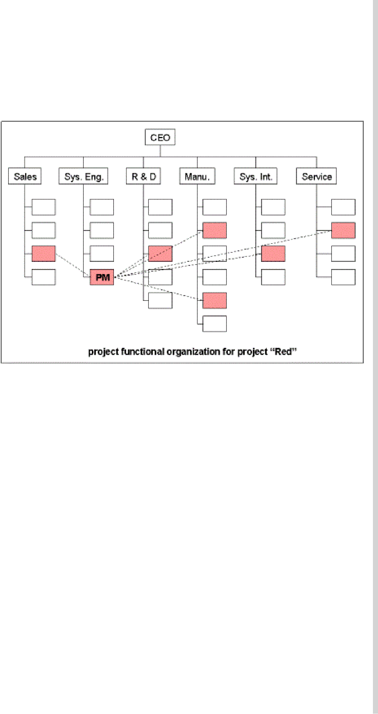

29

Notes

***b) Organizing Projects as Dedicated Teams***



In this structure, a dedicated independent project teams are created. These teams operate as separate units from the rest of the parent organization. Usually, a full time project manager is designated to pull together a core group of specialists who work full time on the project. The project manager recruits necessary personnel from both within and outside the parent company. Project managers get maximum freedom in this structure. The following figure shows how projects are organized with dedicated teams.

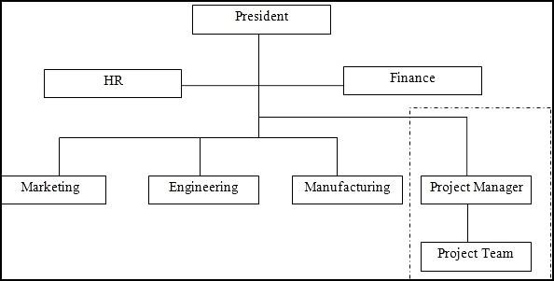

**Managing Projects as dedicated teams**

30

Notes

1. **Organizing Projects within a Matrix Structure**



Matrix management is a hybrid organizational form in which a horizontal project management structure is overlaid on the normal functional hierarchy. In matrix system, there are two chains of command, one along functional lines and the other along project lines. Instead of delegating segments of a project to different units or creating an autonomous team, project participants report simultaneously to both functional and project managers. Matrix structure is designed to optimally utilize resources by having individuals work on multiple projects as well as being capable of performing normal functional duties. At the same time, the matrix approach attempts to achieve greater integration by creating and legitimizing the authority of a project manager. The following figure shows how projects are managed in matrix structure.

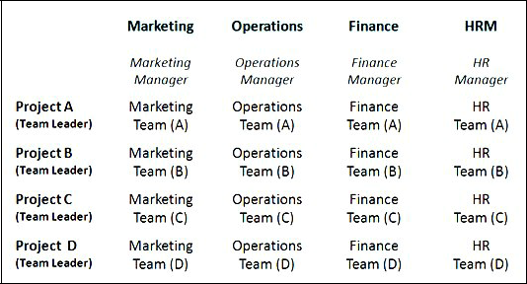

**Managing Projects within a Matrix Structure**

31

Notes

32

Notes

1. **Organizing projects within network organizations**



There have been a lot of changes in the organizational structures and the recent one being the network structure. Corporate downsizing and cost control have combined to provide what we call network organizations. Network organization is an alliance of several organizations for the purpose of creating products or services for customers. This collaborative structure typically consists of several satellite organizations bee hived around a hub or core firm. The following figure shows the network structure of Amazon.com, a networked organization.

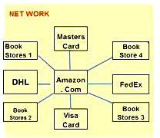

**Network of Amazo.com, a Networked Organization**

Another example is the film industry where studios such as MGM, Warner Brothers, and 20th Century Fox owned large movie lots and employed thousands of full time specialists. Today movies are made by a collection of individuals and small companies who come together to make films project by project. This structure allows each project to be staffed with the talent most suited to its demands rather than choosing from only those people the studio employs.

33

* .

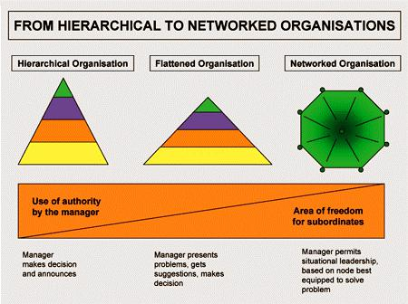

34

Thus, the project characteristics and organizational structure can be related and the same is shown in the following figure.

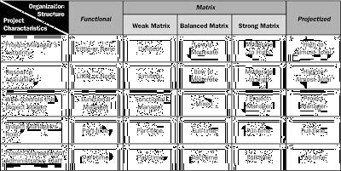

**Project Characteristics and Organizational Structure**

35

Notes

.

36

Notes

**Understand the Impact of Culture on a PMO**



Every organization has a unique culture, created through years of leadership and staffed with individuals who share common values and work ethics. Matching the right project office structure with organizational culture is critical for success. PMOs are not “one size fits all” solutions. In fact, PMO structures include an entire spectrum of options each with different structures, roles and responsibilities, reporting lines, resources, and levels of authority.

A successful project office can range from simple project data reporting to a centralized structure that takes the lead on every aspect of project management. Deciding on your organization’s PMO requires evaluating the characteristics of your organization, as well as clarifying your expectations of the project office.

37

Notes

.

38

Notes

**Conclusion**

No matter what structure your organization chooses, the implementation process itself is the key to the success of your project office. A champion should be identified to assist in promoting the benefits of good project management and helping to clear roadblocks to change. The champion will often create a cross functional steering team to help with the PMO implementation steps. Culturally, most organizations should begin with a less controlling, de-centralized project office, at least until the staff becomes comfortable working in a matrix-managed environment. A well-defined, effective project management office can be an important step to greater success for your organization.

****

39

Notes



**1.3 - Steps in Defining Project and Project Delays**

**Step 1: Defining the Project Scope**

The first step in defining the project is defining its scope. Project scope is a definition of the end result or mission of the project – a product or service for the customer or client. The primary objective is to define as clearly as possible the deliverables for the end user and to focus project plans. The scope should be developed under the direction of the project manager and customer. The project manager is responsible for seeing that there is agreement with the owner on project objectives, deliverables at each stage of the project and technical requirements. The project scope definition is a document that will be published and used by the project owner and project participants for planning and measuring project success. Scope describes what the organization expects to deliver to the

40

Notes

customer when the project is complete. The project scope should define the results to be achieved in specific, tangible and measurable terms.





**Step 2: Establishing Project Priorities**

Quality and the ultimate success of a project are traditionally defined as meeting and/or exceeding the expectations of the customer and/or upper management in terms of cost (budget), time (schedule), and performance (scope) of the project. The interrelationship among these criteria varies. One of the primary jobs of a project manager is to manage the trade-offs among time, cost and performance. To do so, project managers must define and understand the nature of the priorities of the project. They need to have a candid discussion with the project customer and upper management to establish the relative importance of each criterion. One technique that is useful for this purpose is completing a priority matrix for the project that identifies which criterion is constrained, which should be enhanced and which can be accepted.

42

Notes

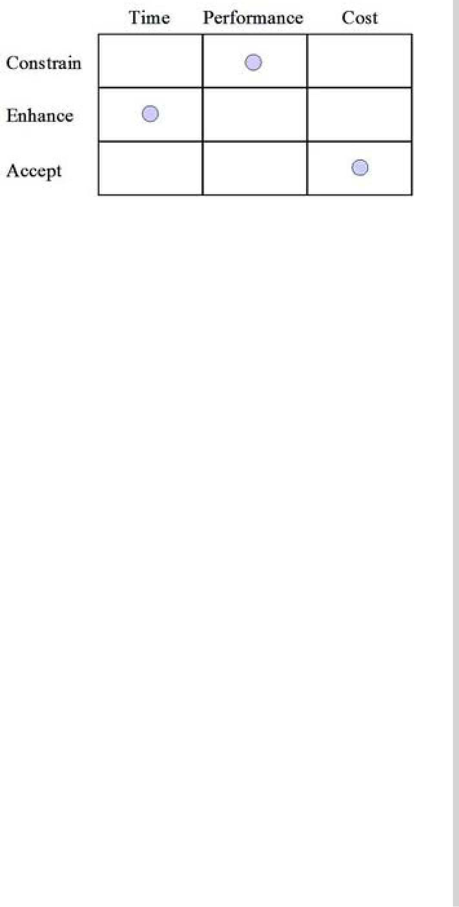

**Project Priority Matrix**

**Step 3: Creating the Work Breakdown Structure**

The Work Breakdown Structure (WBS) is a tree structure, which shows a subdivision of effort required to achieve an objective; for example a program, project, and contract. The WBS may be hardware, product, service, or process oriented. A WBS can be developed by starting with the end objective and successively subdividing it into manageable components in terms of size, duration, and responsibility (e.g., systems, subsystems, components, tasks, subtasks, and work packages), which include all steps necessary to achieve the objective. The WBS provides a common framework for the natural development of the overall planning and control of a contract and is the basis for dividing work into definable increments from which the statement of work can be developed and technical, schedule, cost, and labor hour reporting can be established. Work Breakdown Structure (WBS) is defined by PMBOK Guide as: “A deliverable-oriented hierarchical decomposition of the work to be executed by the project team to accomplish the project objectives and create the required deliverables.” The following figure shows the hierarchical breakdown of the WBS.

43

Notes

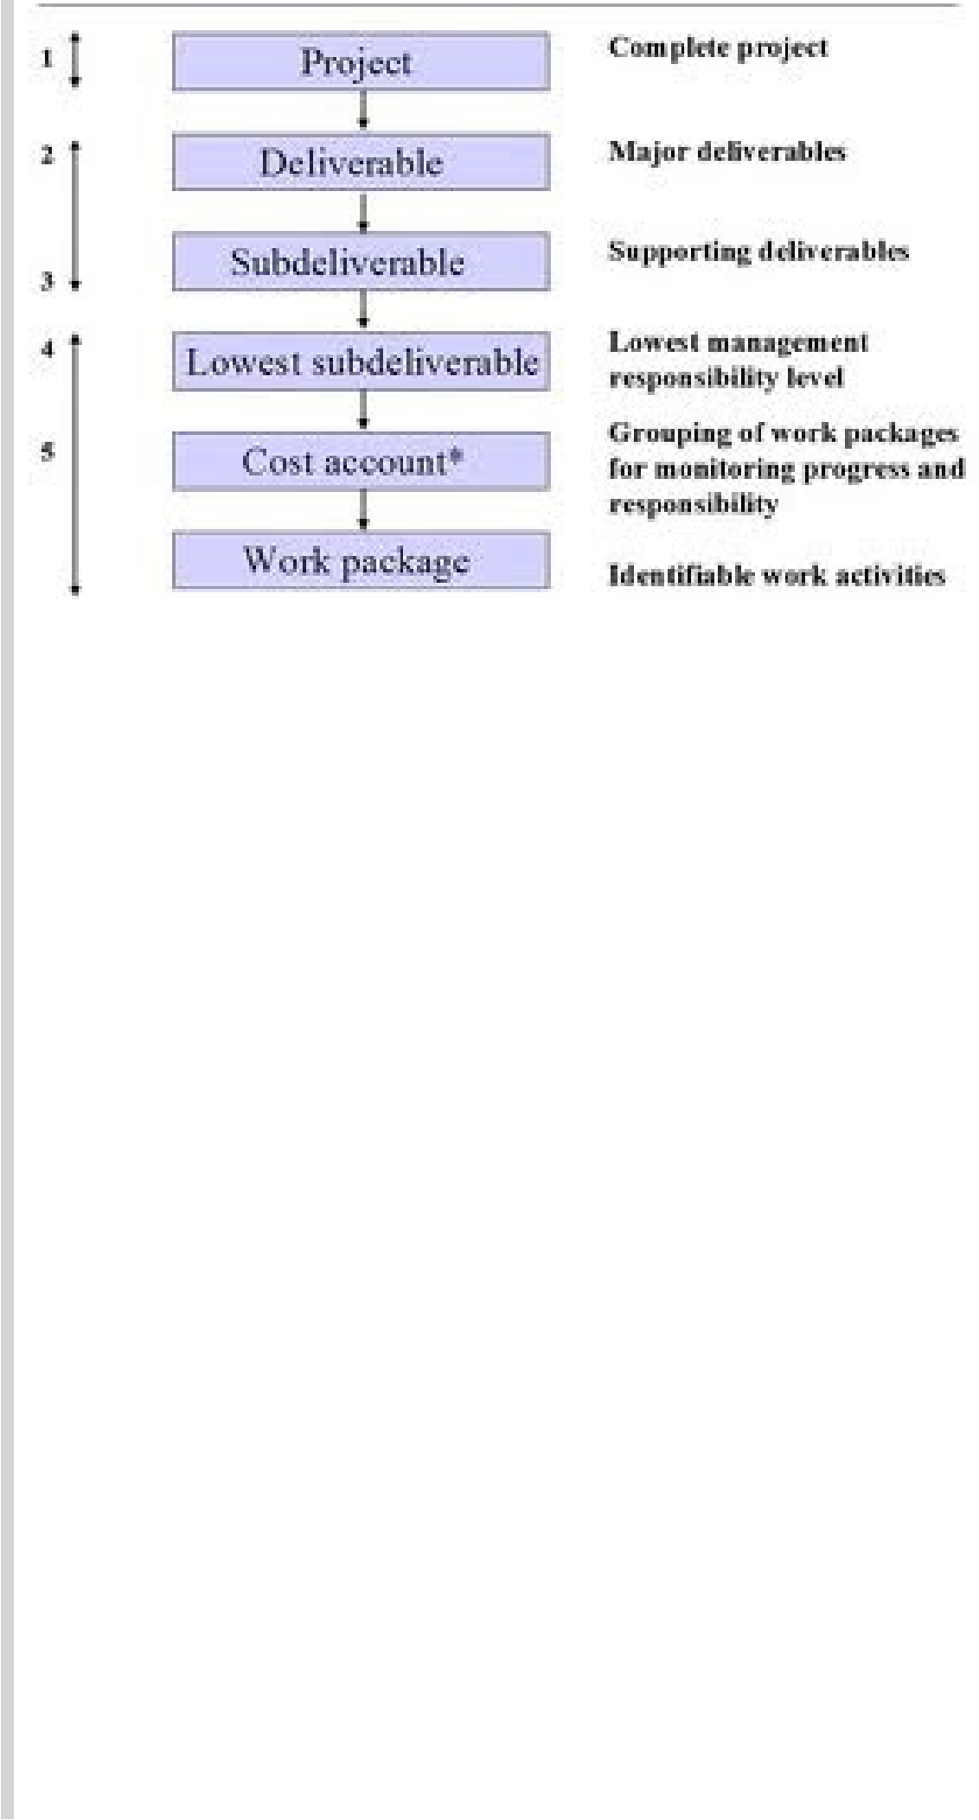

**Hierarchical Breakdown of the WBS**

***Process of Creating a WBS***

There are several **inputs** you will need to get you off on the right foot:

* The Project Scope Statement
* The Project Scope Management Plan
* Organizational Process Assets
* Approved Change Requests

These inputs should give you all the information you and your team needs to create your WBS. Along with these inputs, you will use

44

Notes

The first step to creating your WBS is to get all your team, and possibly key stakeholders, together in one room. Although your team is not listed as an input or tool in the above sections, they are probably your most vital asset to this process. Your team possesses all the expertise, experience, and creative thinking that will be needed to get down to the specifics of each deliverable. Next, we have to get the first two levels setup. The first level is the project title, and the second level is made up of all the deliverables for the project. At this stage it is important to function under the 100% Rule. This rule basically states that the WBS (specifically the first two levels) includes 100% of all the work defined in the project scope statement and management plan. Also, it must capture 100% of all the deliverables for the project including internal, external, and interim. In reality the WBS usually only captures between 90-95%, and 100% is our goal. The following diagram shows the WBS.

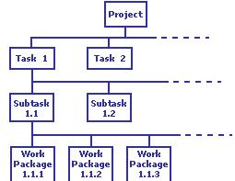

**Work Breakdown Structure**

45

Notes

46

Notes

47

Notes



**Step 4: Integrating the WBS with the organization**

An integral part of WBS is to define the organizational units responsible for performing the work. In practice, the outcome of the process is the **organization breakdown structure (OBS).** The OBS depicts how the firm has organized to discharge work responsibility. The purpose of the OBS are to provide a framework to summarize organization unit work performance, identify organization units responsible for work packages and tie the organizational unit to cost control accounts. Cost accounts group similar work packages. The OBS defines the organization sub-deliverables in a hierarchical pattern in successively smaller and smaller units.

**Step 5: Coding the WBS for the Information System**

Coding system is very important to gain the maximum benefit of a work breakdown system. The codes are used to define levels and elements in the WBS, organization elements, work packages, budget and cost information. The codes allow reports to be consolidated at any level in the structure. The most commonly used scheme is numeric indention. Some organizations use alphabet letters and most of the organizations use the combination of both.

48

Notes

**Project Roll-Up**



The intersection of WBS and OBS represents a control point called cost account by project managers. The work packages and cost accounts serve as a database from which all other planning, scheduling and controlling processes are coordinated. Cost accounts include one or more work packages.

Each work package has time, budget, resource, responsibility and control points that can be used to track project progress. Starting with the work package, costs and resources can be rolled up into higher elements which are referred as project rollup. The ability to consolidate and integrate using the rollup process demonstrates the potential value of the WBS for managing the project.

**Process Breakdown Structure**

The WBS is best suited for design and builds projects that have tangible outcomes. The project can be decomposed or broken down into major deliverables, sub-deliverables, and further sub-deliverables and ultimately to work packages. It is more difficult to apply WBS to less tangible, process-oriented projects in which the final outcome is a project of a series of steps or phases.

Here, the difference is that the project evolves over time with each phase affecting the next phase. IT project typically fall in this category. Project projects are driven by performance requirements, not by plan/ blueprints. The following figure shows the process breakdown structure.

49

Notes

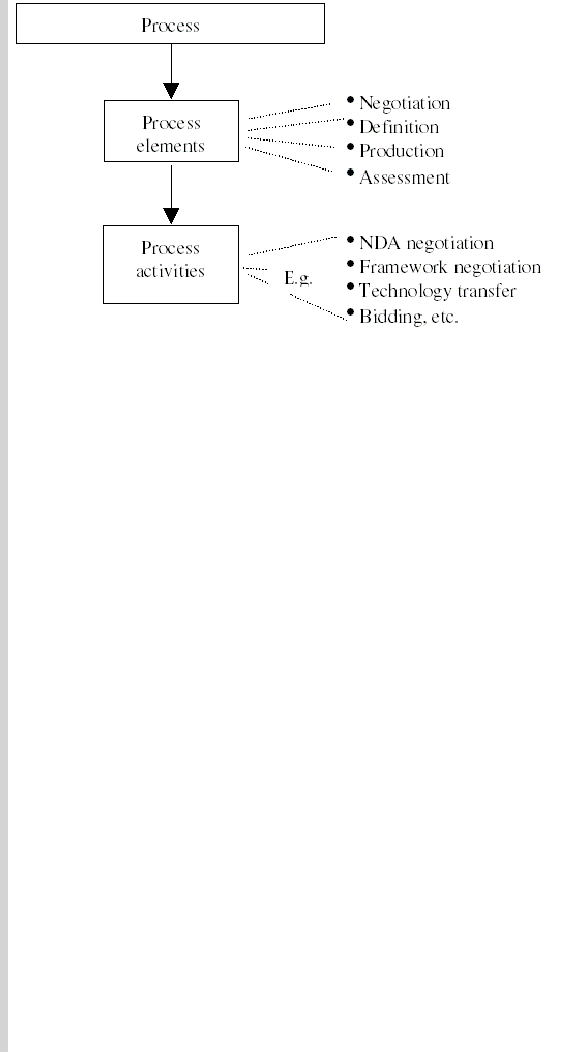

**Process Breakdown Structure**

50

Notes



**Resource 1 Resource 2 Resource 3** **Resource 4**

Activity 1

Activity 2

Activity 3

Activity 4

The intersection points are used to describe each resource’s level of participation for the activity. The participation type codes are inserted in these cells. A legend is included to define the codes. The following figure shows the example of a Responsibility Matrix with Participation Codes.

|  |  |  |  |  |  |
| --- | --- | --- | --- | --- | --- |
|  | **Person 1** | **Person 2** | **Person 3** | **Network** |  |
|  | **Staff** |  |
|  |  |  |  |  |
|  |  |  |  |  |  |
| Review Resumes |  | R | S |  |  |
|  |  |  |  |  |  |
| Interview Applicants | I | R | S |  |  |
|  |  |  |  |  |  |
| Hire Personnel | R | I |  | I |  |
|  |  |  |  |  |  |
| Purchase Equipment | A |  |  | R |  |
|  |  |  |  |  |  |

R=Responsible, A=Approve, I=Inform, S=Support/Assist

As shown in the figure, resources might not have a participation type code for every activity. Every activity should have one resource designated as the one responsible for the activity.

Also, it is recommended that each role for each activity receive just one participation type code. When more than one code is used, it implies that resource’s role has not yet been fully resolved, which can impede the value of this technique in clarifying the level of responsibility for the task.

Because the purpose of the matrix is to gain clarity and agreement on who does what, the columns and rows can be defined with as much detail as makes sense.

For example, a high-level RM can identify what project team group is responsible for each component of the work breakdown structure, while lower-level RMs can be used to designate the participation level of specific group members for specific activities.

51

Notes

**RACI**

There are a number of ways to create a Responsibility Matrix using different participation types. One common version is called the RACI matrix. **RACI** is an acronym derived from the four key responsibilities most typically used: Responsible, Accountable, Consulted and Informed. It is used to show the connections between work that needs to be done and project team members. This is a highly versatile tool that can be easily modified to suit multiple project needs. RMs can be developed at various levels of detail, from high to low. It can be used during any project phase, including the post-implementation support phase, and is especially useful when activities require coordination between several different groups, agencies, or vendors. Following Figure is a sample RACI chart.

|  |  |  |  |  |  |  |  |
| --- | --- | --- | --- | --- | --- | --- | --- |
| **Activity** | **Person** | **Person** | **Person** | **Person** | **Person** | **Person** |  |
| **1** | **2** | **3** | **4** | **5** | **6** |  |
|  |  |
|  |  |  |  |  |  |  |  |
| Investigate | R | A | I | C | C |  |  |
| Design | I | A | C |  |  | R |  |
| Software |  |  |  |
|  |  |  |  |  |  |  |
| Develop | R | A | I |  |  | C |  |
| UAT Plan |  |  |  |
|  |  |  |  |  |  |  |
| Obtain | R | A | I | C | C | C |  |
| Signoff |  |
|  |  |  |  |  |  |  |

R=Responsible, A=Accountable, C=Consulted, I=Informed

52

53

Notes

.

54

Notes

Notes

56

Notes





****

60

Notes



61

Notes



**2.1 - Various Stages and Components of**

**Project Feasibility Studies**

**Opportunity Studies**

Identifying suitable opportunities for investment is an intricate and involved exercise in developing countries. A variety of constraints, complexities, risks and uncertainties have to be reckoned with, and their implications on the project implementation and its subsequent success in the operational phase have to be carefully and thoroughly examined before the resources are committed. Efforts in identifying these opportunities pursued at different levels. The enterprise management is expected to take all initiative to convince itself about the prospects of the project that it wishes to launch.

62

Notes

63

Notes

64

Notes

65

Notes

66

Notes

**Functional Studies or Support Studies**

These are confined to selected aspects of the project being contemplated, and may be found necessary by way of support for pre-feasibility or feasibility studies, particularly in the case of large projects with multi-division, multi-product characteristics. The following types of studies are found to be common:

**Market studies**: The thrust is on examining the market prospectsof the products proposed to be manufactured. Demand estimates have to be prepared and, in addition, scope for market penetration or creation of a new demand through suitable market strategies have to be assessed.

67

Notes

**Materials input studies:** The ready availability of raw materialsand other essential inputs has to be examined, and reliable sources for these supplies have to be identified. Need for developing proximate sources of supply for critical items or components through vendor development initiatives have to be assessed, as this would involve additional project outlays. The prevailing and anticipated price trends for these items have also to be studied.



.

**Equipment selection studies:** Very large projects with multipledivisions and products have to procure equipment from diverse sources. Certain common services like central tool room or common annealing, heat treatment, plating, metallurgical testing and other services can be planned, if found feasible, with substantial savings on capital costs. These possibilities have to be examined through special studies.

**Laboratory and pilot plant tests:** To prove the suitability of rawmaterials or components or processes, laboratory tests or pilot plant tests may have to be resorted to.

68

Notes



**Components of Project Feasibility Studies**

**Introduction**

The United Nations Industrial Development Organization (UNIDO) has published in the ***Manual for the Preparation of Industrial*** ***Feasibility Studies*** to help the standardization of industrial feasibilitystudies, which have often found to be incomplete and inadequately prepared. It will be useful to trace the components, or contents, of the feasibility studies through the framework provided by UNIDO.

**Components of Techno-Economic Feasibility Studies**

Following are the contents of techno-economic feasibility studies:

1. Project background and history
2. Demand and market study
3. Demand projections
4. Forecasting techniques
5. Export projections
6. Market penetration
7. Sensitivity analysis
8. Sales forecast and marketing
9. Production programme
10. Plant capacity
11. Materials and inputs
12. Supply programme
13. Project location

69

Notes

* 1. Plant site, within the location
  2. Local conditions
  3. Layout and physical coverage of project
  4. Technology and equipment
  5. Civil engineering
  6. Plant organization
  7. Overhead costs
  8. Labour
  9. Staff
  10. Implementation scheduling
  11. Financial evaluation
  12. Economic evaluation

74

Notes

* .

75

Notes

79

Notes

80

Notes

**Detailed Project Report (DPR)**

Detailed Project Report is one which contains the complete details of the project and it is required to be submitted to banks and financial institutions for obtaining the financial assistance. Usually, all the con-tents of techno-economic feasibility studies will be covered in the DPR.

83

Notes

1. .

84

Notes



**Conclusion**

The Detailed Project Report (DPR) is an essential building block for the projects and enabling sustainable quality service delivery. The DPR is to be prepared carefully and with sufficient details to ensure appraisal, approval, and subsequent project implementation in a timely and efficient manner. This document provides a reference format for preparing DPRs/ Project Reports across sectors.

****

85

Notes



**Lesson 2.2 - Phases of Project, Project Life Cycle Stages and**

**Constraints**

Project life cycle is a complex process consisting of different steps arranged in a sequential order. Different authors have described these steps in different sequential manner but the concept of the cycle is almost similar in each case. According to United Nations Guidelines for Rural Centre Planning, there are 7 steps in the project life cycle such as project identification and appraisal, pre-feasibility study, feasibility study, detailed design project implementation, operation maintenance, monitoring and evaluation.

86

Notes

87

Notes



88

Notes

Notes

**PROJECT Constraints**



**Defining Project Constraints**

To prioritize and define the scope of the application deployment project, gather information about the constraints of your project. Constraints often include:

**Resources:** Identify the equipment, software, staff, and space thatare available for the project.

**Time:** Identify the date by which the application deploymentproject must be completed, and how the application testing process fits into the larger deployment project.

**Organizational issues:** If the project will not involve the entireorganization, identify which groups in your organization will be affected by it. Additionally, determine if a particular group in the organization needs the new operating system sooner than others. If so, you might decide to perform a staged rollout.

**Access to developers:** Identify applications that were developedin-house or especially for your organization. Access to the developers of these applications is critical during the testing and issue resolution phases of the project. Such access also can be an invaluable aid with retail applications. The primary impact of project constraints is the likelihood of delaying the completion of the project. There are three types of project constraints: technological, resource and physical.

**The technological constraints** relate to the sequence in whichindividual project activities must be completed. For example, in constructing a house, pouring the foundation must occur before building the frame.

**Resource constraints** relate to the lack of adequate resources whichmay force parallel activities to be performed in sequence. The consequence of such a change in network relationships is delay in the completion date of the project. We will examine the nature of resource constraints in much greater detail in the next section.

103

Notes

106

Notes



**UNIT - III**

**Project Evaluation**

The main purpose of project evaluation or investment appraisal procedure is simply the comparison of uncertain future cash inflows with cash outflows which might also be uncertain. The basic techniques used by economists and financial analysts for this comparison purpose are most often internal rate of return and net present value techniques. This practice has been so generally accepted that the whole procedure of evaluating the profitability of an investment based on the concept of discounting is often referred to as the discounted cash flow techniques. In this chapter, let us understand the tradition and sophisticated (or discounted cash flow) techniques used for evaluating the projects under certainty; techniques used for evaluating projects under uncertainty; and Project Evaluation methodology including Social Cost Benefit Analysis.

107

Notes



**3.1 - Project Evaluation under Certainty and Uncertainty**

108

Notes

:

109

Notes



:

110

Notes



114

Notes

115

Notes

.

116

Notes

|  |  |  |  |
| --- | --- | --- | --- |
|  |  |  |  |

|  |  |  |  |  |  |  |
| --- | --- | --- | --- | --- | --- | --- |
|  |  |  |  |  |  |  |

117

Notes

|  |  |  |
| --- | --- | --- |
|  |  |  |

118

Notes



**Solution**

|  |  |  |  |  |  |
| --- | --- | --- | --- | --- | --- |
|  |  |  |  |  |  |

119

Notes



120

Notes

121

Notes



|  |  |  |
| --- | --- | --- |
|  |  |  |

122

Notes

Notes



|  |  |  |  |  |
| --- | --- | --- | --- | --- |
|  |  |  |  |  |
|  |  |
|  |  |  |  |  |
|  |  |  |  |  |
|  |  |  |  |  |
|  |  |  |  |  |
|  |  |  |  |  |
|  |  |  |  |  |
|  |  |  |  |  |
|  |  |  |  |  |
|  |  |  |  |  |
|  | |  |  |  |
|  | |  |  |  |
|  | |  |  |  |
|  | |  |  |  |
|  | |  |  |  |
|  |  |  |  |  |

Notes



|  |  |  |  |  |
| --- | --- | --- | --- | --- |
|  |  |  |  |  |

|  |  |  |  |  |
| --- | --- | --- | --- | --- |
|  |  |  |  |  |

125

Notes

.

**Advantages of Discounted Cash Flow Method**

The advantages of discounted cash flow method are as follows:

* Discounted cash flow technique takes into account time value of money.
* The method takes into account directly the amount of expenses and revenues over the project’s life.
* The method automatically gives more weight to those money values which are nearer to the present period than those which are farther from it.
* The method makes possible comparison of projects requiring different capital outlays, having different lives and different timings of cash flows, at a particular moment of time because of discounting of all cash flows.

**Disadvantages of Discounted Cash Flow Method**

The disadvantages of discounted cash flow method are as follows:

* The method is difficult to understand and work out.
* The method takes into account only the cash inflows on account of a capital investment decisions. As a matter of fact, the profitability or otherwise of a capital investment proposal can be judged only when the net income (and not the cash inflow) on account of operations is considered.

126

Notes

* .



127

Notes

132

Notes



**3.2 - Appraisal of Project Evaluation, Commercial and**

**Social Cost Benefit Analysis**



**Steps Involved in Determination of Social or National Profitability**

***1) Real Direct Cost and Real Direct Benefits***

National/Social profitability analysis takes into account the real cost of direct costs and real benefit of direct benefits. For instance, some of the inputs may be subsidized. Only the subsidized prices of input is what is relevant for assessing commercial profitability. However, the national profitability analysis takes into account the real cost of inputs i.e. cost of input had they not been subsidized. Accordingly the required adjustment to direct cost of input are made for national profitability analysis.

***2) Indirect Costs and Indirect Benefits***

National/Social profitability analysis takes into account the indirect costs and indirect benefits to the nation. While a nation bears the indirect cost, the people of the nation enjoy the indirect benefit. Hence, indirect costs and benefits are given due recognition and accounted for in social cost benefit analysis. It is however difficult to assess exactly the quantum of indirect costs and indirect benefits.

Suppose construction of a bridge over a river is taken up. Its indirect benefits may include improved communication facilities reduction in transportation costs, reduction in traveling time, etc., while the indirect cost may include acquisition of private land by the state, removal of industrial, commercial, agricultural activities that prevailed in the land that was acquired, disturbance of ecological balance etc.

National/Social profitability analysis can thus be regarded as a refinement over commercial appraisal taking the hidden factors into account. National/Social profitability analysis is mainly used for evaluating public investment projects. From the society’s standpoint, the project should maximize the aggregate consumption or the addition to the flow of goods and services in the economy. While the individual investor looks for maximization on his individual basis, the society’s interest should look for maximization of the total output of the economy. The need thus

139

Notes

arises to have an analysis done of social costs and social benefits. The various inputs required for the project are drawn out of the resources of the economy and constitute social costs. The outputs of the project represent the social benefits. The inputs of goods and services and the outputs should be valued with reference to their relative value to society.



**Commercial or Financial Profitability**

From the national development point of view, there are always more projects compared to the availability of resources and hence the necessity to appraise projects for selection arises. While the obvious choice will be the projects with higher returns, the complexity arises because of the need to appraise projected outcome based on forecasts in a world of uncertainly, particularly in the context of endemic inflation. In the case of large projects, particularly public sector projects involving the building up of infrastructure it is essential to assess the social merits of the investment proposals.

Projects emanate from diverse and dispersed sources, such as individuals firms or institutions, and government at the state and central levels. In situations where the state government is not the owner of the business, the traditional yard stick of commercial or financial profitability is used for selection of projects for implementation. The financial benefits get related to the financial costs of the project and if there is a net surplus the project merit choice. While the process of selection of individual projects thus meets the profit criteria of the individual investors or promoters, the combination of choices may not necessarily result in the most socials profitable allocation of resources. For developing economies this is the very important factor but it cannot be ignored.

Commercial or financial profitability as the sole deciding factor has two major limitations viz.

1. Financial or market values seldom match with social values and
2. What is beneficial to one segment of society may not necessary be so to the entire society.

In financial analysis the market values of input and outputs are reckoned and compared. And since market distortions are many, these

140

Notes

values fail to reflect the relative worth on the society’s value scale. From society’s stand point, goods and services should be valued in terms of relative contributions to consumption. In the same manner the social value of resource should be reckoned in terms of its opportunity cost, represented by the output or consumption value that it is capable of yielding in its next best alternative use.



**CASE STUDY**

**Financial Evaluation of Projects**

The following information belongs to four investment opportunities:

|  |  |  |  |  |
| --- | --- | --- | --- | --- |
|  | 1 | 2 | 3 | 4 |
| Funds needed | (960,000) | (720,000) | (540,000) | (900,000) |
| Present value | 1,134,540 | 866,800 | 672,280 | 1,045,940 |
| of cash inflows |  |  |  |  |
| Net present | $174,540 | $146,800 | $132,280 | $145,940 |
| value |  |  |  |  |
| Project life | 6 years | 12 years | 6 years | 3 years |
| Internal rate of | 16% | 14% | 18% | 19% |
| return (IRR) |  |  |  |  |

Due to limited funds, all projects cannot be accepted.

149

Notes

**Required**



1. Compute profitability index (present value index) for all the projects.
2. Rank the four investment projects according to (a). net present value (b). profitability index (c). internal rate of return

****

150

Notes



Notes



**4.1- Developing Project Network Using PERT and CPM**

**Developing the Project Network**

The project network is the tool used for planning, scheduling, and monitoring project progress. The network is developed from the information collected for the WBS and is a graphic flow chart of the project job plan. The network depicts the project activities that must be completed, the logical sequences, the inter dependencies of the activities to be completed, and in most cases the times for the activities to start and finish along with the longest path(s) through the network—the critical path. The network is the framework for the project information system that will be used by the project managers to make decisions concerning project time, cost, and performance.

The network is the framework that will be used by the project managers to make decisions concerning project time, cost and performance. Once the network is developed, it is very easy to modify or change when unexpected events occur as the project progresses. Developing the project networks takes time for someone or some group to develop; therefore, they cost money. Are networks really worth the struggle? The answer is definitely yes, except in cases where the project is considered trivial or very short in duration. The network is easily understood by others because the network presents a graphic display of the flow and sequence of work through the project. Once the network is developed, it is very easy to modify or change when unexpected events occur as the project progresses. For example, if materials for an activity are delayed, the impact can be quickly assessed and the whole project revised in only a few minutes

152

Notes

with the computer. These revisions can be communicated to all project participants quickly (for example, via e-mail or project Web site).



Basically, project networks minimize surprises by getting the plan out early and allowing corrective feedback. A commonly heard statement from practitioners is that the project network represents three-quarters of the planning process. Perhaps this is an exaggeration, but it signals the perceived importance of the network to project managers in the field. Project networks are developed from the WBS. *The project network is a* *visual flow diagram of the sequence, interrelationships, and dependencies of all the activities that must be accomplished to complete the project.* An**activity** is an element in the project that consumes time—for example,work or waiting. Work packages from the WBS are used to build the activities found in the project network. An activity can include one or more work packages. The activities are placed in a sequence that provides for orderly completion of the project. Networks are built using **nodes** (boxes) and **arrows** (lines). The node depicts an activity, and the arrow

153

Notes

shows dependency and project flow. The following diagram shows the



WBS/ Work packages to network for a software project:

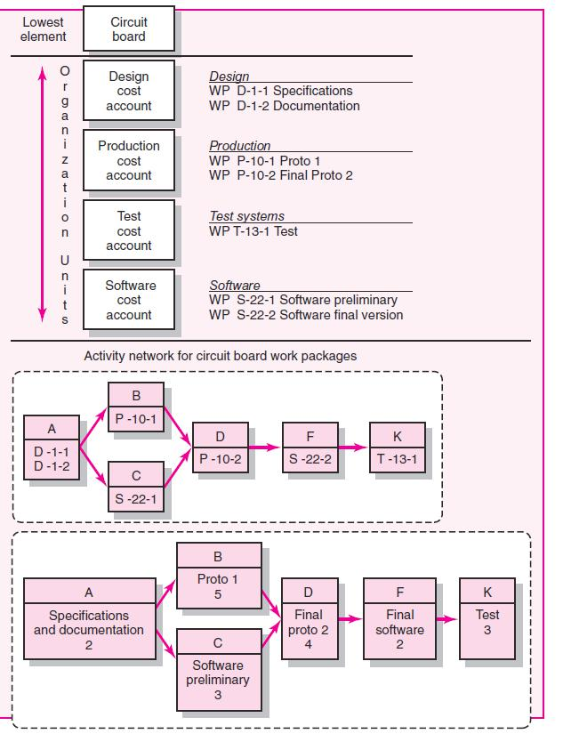

**WBS/Work packages to Network**

The figure shows a segment of the WBS example and how the information is used to develop a project network. The lowest level deliverable in the figure is “circuit board.” The cost accounts (design, production, test, software) denote project work, organization unit responsible, and time phased budgets for the work packages. Each cost account represents one or more work packages. For example, the design cost account has two work packages (D-1-1 and D-1-2)—specifications and documentation. The software and production accounts also have two

154

Notes

work packages. Developing a network requires sequencing tasks from all work packages that have measurable work.





165

Notes

Notes



**4.2 - Crashing and Resource Levelling of Projects**

Crashing refers to a particular variety of project schedule compression which is performed for the purposes of decreasing total period of time (also known as the total project schedule duration). The diminishing of the project duration typically take place after a careful and thorough analysis of all possible project duration minimization alternatives in which any and all methods to attain the maximum schedule duration for the least additional cost.The objective of crashing a network is to determine the optimum project schedule. Crashing may also be required to expedite the execution of a project, irrespective of the increase in cost. Each phase of the project consumes some resources and hence has cost associated with it. In most of the cases cost will vary to some extent with the amount of time consumed by the design of each phase. The total cost of project, which is aggregate of the activities costs will also depends upon the project duration, can be cut down to some extent. The aim is always to strike a balance between the cost and time and to obtain an optimum project schedule. An optimum minimum cost project schedule implies lowest possible cost and the associated time for the project management.

project equals the sum of the direct costs of its activities, then the project direct cost will increase by decreasing its duration. On the other hand, the indirect cost will decrease by decreasing the project duration, as the indirect cost are almost a linear function with the project duration.

The below figure shows the direct and indirect cost relationships with the project duration. The project total time-cost relationship can be determined by adding up the direct cost and indirect cost values together. The optimum project duration can be determined as the project duration that results in the least project total cost.

175

Notes

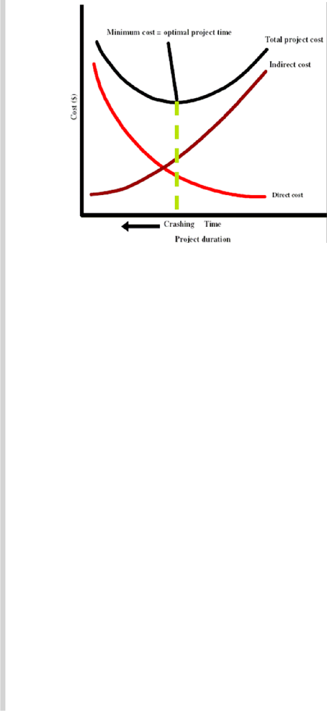

**Project time-cost relationship**



**Conclusion**

The completion of projects without overruns and delays is probably the most important current problem area for cost engineers and project managers as well as for the image of the whole professional area of Cost Engineering / Project Cost Control not to mention the owners/contractors and users themselves. Commercial Risk Analysis is therefore one of the basic sub-procedures used by cost engineers.

****

184

Note

**4.3 - Project Appraisal and Control Process**

.

Project appraisal management is an essential stage of any project, regardless of its nature, type and size. This stage represents the first point of the pre-planning or initiation phase. Without having appraised a project, it is financial and technically unreasonable to proceed with further planning and development. No matter whether you are going to purchase a new car (e.g. my neighbour’s project), constructing a building, improving a business process, updating a network system, conducting a marketing campaign, building a garage, or any other initiative, you should make a preliminary assessment and appraisal of your undertaking in order to be sure that that you will do a required and necessary change to your environment.

**Project Control Process**

**Project Controls**

It is a management action, either planned to achieve the desired result or taken as a corrective measure prompted by the monitoring process. Project controls are mainly concerned with the metrics of the project, such as quantities, time, cost and other resources. Apart from these, project revenues and cash flow can also be part of the project metrics under control.

The successful performance of a project depends on appropriate planning. The execution of a project is based on a robust project plan and can only be achieved through an effective schedule control methodology. The development of a suitable Project Control system is an important part of the project management effort. Furthermore, it is widely recognized that planning and monitoring plays a major role as the cause of project failures. It has been proved time and again that Project performance can be improved if dedicated Project Controls systems are in place.

**Project Control Process**

Control is the process of comparing actual performance against plan to identify deviations, evaluate possible alternative courses of actions, and take appropriate corrective action. The steps in the project control process for measuring and evaluating project performance are listed below:

* Setting a baseline plan.
* Measuring the actual performance
* Comparing actual with baseline plans.
* Taking corrective action.



**Conclusion**

Controls usually relate to stages in projects and are established to control the delivery of the project’s products (outputs). In project management controls take two forms - event driven and time driven. Event driven means that the control occurs because of a specific event has taken place. Examples of event driven controls include End-Stage Reports, completion of a Project Initiation Document (PID) and creation of an

200

Notes

exception plan. Time driven controls are regular progress feedbacks. Examples of time driven controls include checkpoint and highlight reporting. This does not replace the need for the Board to maintain an overall view of progress. Monitoring is used to oversee progress of products, outputs, and outcomes. Reporting advises the correct people at the correct time of positive and negative events, allowing for progression or remedial action as appropriate. Controls then assist with both monitoring and reporting by provision of required review points such as End Stage Assessments.



****

201

Notes



**4.4 - Project Audit and Evaluation of Project Team and its**

**Manager**

Project audits are more than the status reports which check on project performance. Project audits use performance measures and forecast data. But project audits are more inclusive. Project audits review why the project was selected. It includes a reassessment of the project’s role in the organization’s priorities. It includes a check on the organizational culture to ensure that it facilitates the type of project being implemented. It assesses if the project team is functioning well and it is appropriately staffed. Audits of projects in process should include a check on external factors that might change where the project is heading on the right path

– for example, technology, government regulations, and competitive products. It includes a review of all factors relevant to the project and to managing future projects. It can be performed while a project is in process and after a project is completed. There are only a few minor differences between these audits.

***In-Process Project Audits***

In-process project audits allow for corrective changes, if they are needed, on the audited projects or others in progress. It concentrates on project’s progress and performance and checks if conditions have changed.

202

Notes

**Individual Team Member and Project Manager Evaluation**



Team evaluation is crucial, but at some point a project manager is likely to be asked to evaluate the performance of individual members. Such an evaluation will typically be required as part of the closure process and will then be incorporated in the annual performance appraisal system of the organization. These evaluations constitute a major element of an individual’s personnel file and often form the basis for making the decisions about promotions, future job assignments, merit pay increases, and other rewards.

**Peer Evaluation**

Peer evaluations offer an opportunity for team to comment on the performance of their peers. For example, the team may ask its members at a midpoint in the project to self-evaluate their improving team effectiveness. The goal is to provide information during the project that will allow the participants to modify their behaviour for the success of the project. In the recent times, 360 degree feedback is gaining momentum in the organizations. 360 degree feedback is a multi-rater approach and involves soliciting feedback relating to the performance of team members from all the stakeholders of the project. This includes not only the project and area managers but also peers, subordinates and customers.

215

**5.1 - Project Managing Versus Leading of Projects**

In a perfect world, the project manager would simply implement the project plan and the project would be completed. The project manager would work with others to formulate a schedule, organize a project team, keep track of progress and announce what needs to be done next week and then everyone would follow. But in reality, no one lives in a perfect world and not all things are going as per the plans. The following may likely to happen in reality:

1. Project Participants Get Impatient
2. Project Team Members Fail To Complement Each Other
3. Service Departments Are Unable To Fulfill Their Commitments
4. Technical Problems Arise
5. Work Completion Take Longer Time Than Expected
6. Cost May Overrun.

216

***Project Stakeholders***

Depending on the nature of the project, there are a number of different groups outside the organization that influence the success of the project. Examples of project stakeholders include the customer, the user group, the project manager, the development team, the testers, etc. Stakeholder is anyone who has an interest in the project. Project stakeholders are individuals and organizations that are actively involved in the project, or whose interests may be affected as a result of project execution or project completion.

They may also exert influence over the project’s objectives and outcomes. The project management team must identify the stakeholders, determine their requirements and expectations, and, to the extent possible, manage their influence in relation to the requirements to ensure a successful project. Each of the group of stakeholders brings different expertise, standards, priorities, and agendas to the project. The sheer

222

Notes

Notes



**5.2 - Qualities of Project Manager and Managing Projects**

An effective project leader is oftendescribed as having a vision of where to go and the ability to articulate it. Visionaries thrive on change and being able to draw new boundaries. It was once said that a leader is someone who “lifts us up, gives us a reason for being and gives the vision and spirit to change.” Visionary leaders enable people to feel they have a real

230

Notes

stake in the project. They empower people to experience the vision on their own. According to Bennis “They offer people opportunities to create their own vision, to explore what the vision will mean to their jobs and lives, and to envision their future as part of the vision for the organization.” (Bennis, 1997).



.

**Managing a Project Team**

Managing project teams is the art and science of managing relatively short-term efforts having finite beginning and ending points. The concept of project management involves two equally important components of hardware and software. The hardware of tools and systems make it a science. However, there are other things in managing projects than just applying analytical tools to help monitor, track and control. In managing a project team, a Project Manager needs to possess excellent analytical and organizational skills. A technical proficiency in the specialist area of their project is also a distinct advantage. Remember, though, that projects

233

Notes

Notes



**5.3 - Team Building Models, Performance**

**Teams and Team Pitfalls**

**Five Stages of Group Development**

.

**Stage 1: Forming**

In the Forming stage, personal relations are characterized by dependence. Group members rely on safe, patterned behavior and look to the group leader for guidance and direction. Group members have a desire for acceptance by the group and a need to be known that the group is

238

Notes

safe. They set about gathering impressions and data about the similarities and differences among them and forming preferences for future sub grouping. Rules of behavior seem to be to keep things simple and to avoid controversy. Serious topics and feelings are avoided. The major task functions also concern orientation. Members attempt to become oriented to the tasks as well as to one another. Discussion centers around defining the scope of the task, how to approach it, and similar concerns. To grow from this stage to the next, each member must relinquish the comfort of non-threatening topics and risk the possibility of conflict.



**Stage 2: Storming**

The next stage, called Storming, is characterized by competition and conflict in the personal relations dimension an organization in the task-functions dimension. As the group members attempt to organize for the task, conflict inevitably results in their personal relations. Individuals have to bend and mold their feelings, ideas, attitudes, and beliefs to suit the group organization. Because of “fear of exposure” or “fear of failure,” there will be an increased desire for structural clarification and commitment. Although conflicts may or may not surface as group issues, they do exist. Questions will arise about who is going to be responsible for what, what the rules are, what the reward system is, and what criteria for evaluation are. These reflect conflicts over leadership, structure, power, and authority. There may be wide swings in members’ behavior based on emerging issues of competition and hostilities. Because of the discomfort generated during this stage, some members may remain completely silent while others attempt to dominate. In order to progress to the next stage, group members must move from a “testing and proving” mentality to a problem-solving mentality. The most important trait in helping groups to move on to the next stage seems to be the ability to listen.

**Stage 3: Norming**

In the Norming stage, interpersonal relations are characterized by cohesion. Group members are engaged in active acknowledgment of all members’ contributions, community building and maintenance, and solving of group issues. Members are willing to change their preconceived ideas or opinions on the basis of facts presented by other members, and they actively ask questions of one another. Leadership is shared, and

239

Notes

cliques dissolve.



**Stage 4: Performing**

The Performing stage is not reached by all groups. If group members are able to evolve to stage four, their capacity, range, and depth of personal relations expand to true interdependence. In this stage, people can work independently, in subgroups, or as a total unit with equal facility. Their roles and authorities dynamically adjust to the changing needs of the group and individuals. Stage four is marked by interdependence in personal relations and problem solving in the realm of task functions. By now, the group should be most productive. Individual members have become self-assuring, and the need for group approval is past. Members are both highly task oriented and highly people oriented. There is unity: group identity is complete, group morale is high, and group loyalty is intense. The task function becomes genuine problem solving, leading toward optimal solutions and optimum group development. There is support for experimentation in solving problems and an emphasis on achievement. The overall goal is productivity through problem solving and work.

**Stage 5: Adjourning**

The final stage, adjourning involves the termination of task behaviors and disengagement from relationships. A planned conclusion usually includes recognition for participation and achievement and an opportunity for members to say personal goodbyes. Concluding a group

240

Notes

**Situational Factor Affecting Team Development**

Experience and research indicate that high-performing project teams are much more likely to develop under the following conditions:

* There are 10 or fewer members per team
* Members volunteer to serve on the project team
* Members serve on the project from beginning to end.
* Members are assigned to the project full-time.
* Members are part of an organizational culture that fosters cooperation and trust all relevant functional areas are represented on the team
* The project involves a compelling objective
* Members are located within conversational distance of each other

**Project Team Pitfalls**

High performance project teams can produce dramatic results however like any other good thing there is a dark side to project teams that managers need to be aware of. In this section we examine more detail some of the pathologies that the high performing project teams can suc-cumb to and high light what project managers can do to reduce the likeli-hood of these problems occurring.

**a) Groupthink**

Janis first identified groupthink as a factor that influenced the mis-guided 1961 Bay of Pigs invasion of Cuba, his term refers to the tendency of members in highly cohesive groups to lose their critical evaluative capa-bilities. This malady appears when pressures for conformity are combined with an illusion of invincibility to suspend critical discussion of decisions. As a result decisions are made quickly with little consideration of alterna-tives; often the practice leads to fiascos that, after the fact, appeared totally improbable. Some of the symptoms of group think include the following:

Notes



.

**b) Bureaucratic Bypass Syndrome**

Project teams are often licensed to get things done without having to go through normal protocols of the parent organization. Bypassing bureaucratic channels is appealing and invigorating. However, if bypassing becomes a way of life, it results in the rejection of bureaucratic policies and procedures, which provide the glue for the overall organization. A team that operates outside the organization may alienate other workers who are constrained by the norms and procedures of the organization; eventually, these outside bureaucrats will find ways to put up road blocks and thwart the project team.

**c) Entrepreneurs Disease**

Project teams can be intoxicating in the same way that start up ventures are. Such intoxication is exciting and contributes greatly to the success of the team. But abuse can occur as the team makes decision based on what is best for the project instead of on what’s best for parent organization. The team becomes myopic in its focus and often views the constraints imposed by the parent organization or something to overcome. When this attitude occurs on developmental project the team members, enthralled with their accomplishments sometimes quit the parent organization and start their own business. While starting a new venture may be good for the project team, it does little for the parent organization that sponsored and financed the development work.

249

Notes

**d) Team Spirit Becomes Team Infatuation**



High-performing project teams can be tremendous source of personal satisfaction. The excitement, chaos, and joy generated by working on a challenging project can be an invigorating experience. Leavitt and Lipman-Blumen even go so far as to say that the team members behave like people in love. They become infatuated with the challenge of the project and the talent around them. This total preoccupation with the project and the project team, while contributing greatly to the remarkable success of the project, can leave in its wake a string of broken professional and personal relationships that contribute to burnout and disorientation upon completion of the project.

**e) Going Native**

Going native is a phrase first used by the British Foreign Service during colonial times to describe agents who assumed the customs, values and prerogatives of their foreign country assignment, they did so to the point that they were no longing representing the best interest of the British empire but rather those of the natives. This same phenomenon can occur within the project teams working abroad or in those who become closely identified with their customers. In essence, the customer’s interest takes precedent organizations interests. This change in view point can lead to excessive scope creep and open defiance of corporate policy and interests.

**Conclusion**

Dealing with these maladies is problematic because, in most cases, they are a distortion of a good thing, rather than a simple evil. Awareness is the first step for prevention. The next step is to take pre-emptive action to reduce the likelihood of these pitfalls occurring. For example, managers can reduce the isolation of the project team by creating work-related connections outside the project team. These include interactions naturally occur in a matrix environment where members work on multiple projects and maintain ties to their home department. Likewise, the isolation of dedicated project teams can be reduced by the timely involvement of external specialists. In either case, the active involvement of relevant members of the parent organization at project status meetings can help maintain the link between the project and the rest of the organization.

250

Notes